EENG 385 - Electronic Devices and Circuits

Lab 2 – Schmitt Trigger Relaxation oscillator

Lab Handout

# Objective

The objective of this lab is to introduce you to the use of positive feedback in the construction of an oscillator.

# Analysis Schmitt Trigger Relaxation Oscillator

During today’s lab you will build the circuit shown in Figure 1, a Schmitt Trigger Relaxation Oscillator. At the outset, I need to be clear, the engineering objectives of this lab could be accomplished with a 555 timer. However, the education objective of this lab is to explore the use of positive feedback in an op amp to generator oscillatory behavior.

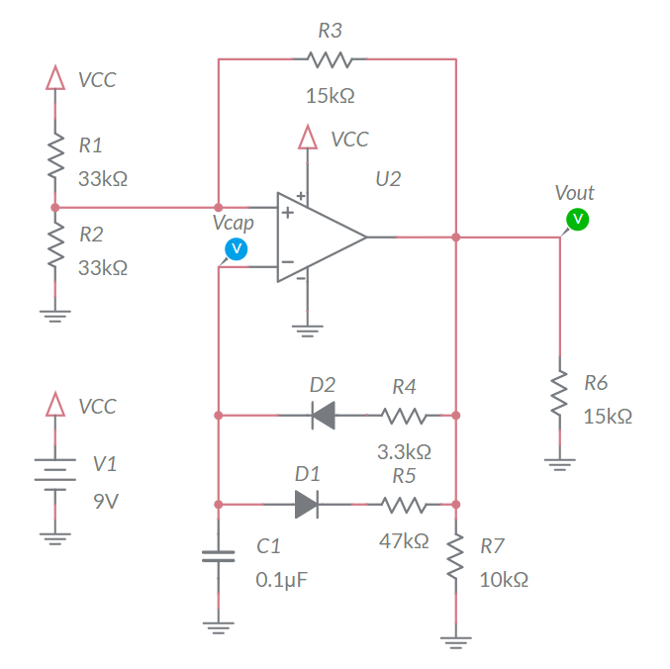

Figure : The Schmitt Trigger Relaxation Oscillator.

In order to analyze the circuit in Figure 1, you need to understand the behavior of a Schmitt Trigger; a circuit with one input, Vin, and one output, Vout. The Schmitt Trigger compares Vin against two voltage levels, Vhigh and Vlow and assigns the output as follows:

* If (Vin > Vhigh) then Vout = VCC
* If (Vin < Vlow) then Vout = 0V
* If (Vlow < Vin < Vhigh) then Vout remains unchanged

This behavior is captured in Figure 2, a graph of Vin vs. Vout.

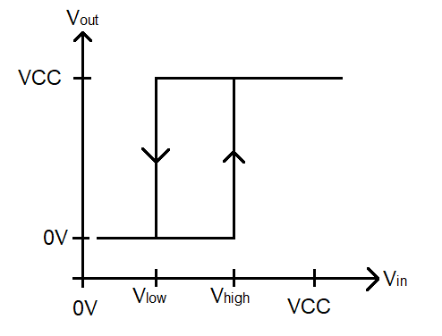

Figure : Input, output relationship for a Schmitt Trigger is characteristic of a system with hysteresis. This is not the answer to question 9 below.

To understand Figure 2, use your finger to point to the region of the horizontal axis (the Vin axis) which corresponds to Vin > Vhigh. Look above this region and you will see a horizontal line that corresponds to Vout = VCC. Likewise for Vin < Vlow you should see that Vout = 0V. The tricky part of the graph is when Vin is between Vlow and Vhigh. In this region Vout holds on to the value it had before Vin entered the region between Vlow and Vhigh.

For example, let’s say that Vin = VCC, so we know for sure that Vout = VCC. Now, let Vin decrease slowly, all the while Vout will stay at VCC. At some point Vin will become equal to and then just a smidge lower than Vhigh. At this point Vhigh will remain unchanged at stay at VCC. As Vin decreases towards Vlow, Vout will remain at VCC. Only when Vin decreases, just a smidge, below Vlow will Vout switch its value to 0V. This transition is represented in Figure 2, by the downward arrow on the line connecting VCC to 0V at Vin = Vlow.

Similarly, as Vin increases from 0V towards Vhigh, the output, Vout will stay at 0V. Only when Vin increases above Vhigh will the output change to VCC. This transition is represented in Figure 2, by the upward arrow on the line connecting 0V to VCC at Vin = Vhigh.

Systems with hysteresis are well suited to reject noise from signals. Consider the example shown in Figure 3 where the top analog signal (red line) is converted into digital signal. The middle signal shows how the analog is converted when a single threshold (the grey line between Vhigh and Vlow) is used to classify the analog signal as 1 when it is above the grey line and 0 when the analog signal is below the grey line. Any noise on the analog signal will cause this scheme to make several digital transitions.

The bottom graph in Figure 3 shows how the analog signal is converted when two thresholds, Vhigh and Vlow, and hysteresis are used to classify the analog signal. In this scheme, the signal is classified as 0 when the analog signal is below Vlow and classified as 1 when the analog signal is above Vhigh. When the analog signal is between the two thresholds, it retains its previous value. The resulting digital signal is much more immune to noise on the analog signal.

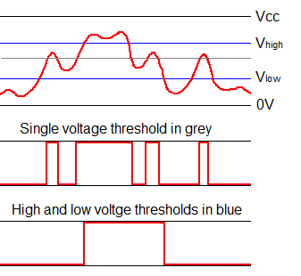

Figure : The top signal (in red) is converted into a digital signal using 1 threshold (middle) and 2 thresholds (lower).

Figure 4 shows a Schmitt Trigger built using an op amp and resistors. Can you identify the parts of this circuit that are used in the circuit shown in Figure 1? Note that the resistors are the same in both figures.

# 

Figure : A Schmitt Trigger built using an op amp.

Answer the following questions to understand its behavior of the circuit in Figure 4. Note this circuit operates differently than the hysteresis diagram in Figure 2.

1. Assume Vout = 9V, what is the voltage at the non-inverting input of the op amp? Call this voltage Vhigh. Hint, ignore the inverting input, put R4 and R8 in parallel and then use voltage divider.
2. Assume Vout = 0V, what is the voltage at the non-inverting input of the op amp? Call this voltage Vlow. Hint, ignore the inverting input, put R4 and R6 in parallel and then use voltage divider.
3. Imagine Vin is at 0V, what is Vout? Hint, the voltage on the non-inverting input of the op amp is at least Vlow.
4. Imagine increasing Vin from 0V to just below Vhigh, what is Vout? Hint, use Vout from the Q3 (you are starting at 0V) to determine the value of non-inverting op amp input from Q1.
5. Imagine Vin continues to increase and goes just above Vhigh, what is Vout?
6. Imagine Vin is at 9V, what is Vout? Hint, the voltage on the non-inverting input of the op amp is at least Vhigh.
7. Imagine decreasing Vin from 9V to just above Vlow, what is Vout? Hint, use Vout from the Q6 (you are starting at 9V) to determine the value of non-inverting op amp input from Q2.
8. Imagine Vin continues to decrease and goes just below Vlow, what is Vout?
9. Use this information to draw Vin vs. Vout hysteresis diagram similar (but not identical) to Figure 2. Label the Vin axis with the voltage values for Vlow and Vout you found in Q1 and Q2.

Now that you have a solid understanding of the Schmitt Trigger circuit in Figure 4, it’s time to apply that understanding to the operation of the larger circuit in Figure 1. Do this by working through the following questions.

1. Assume Vout = 9V. In this case, there is a path for electrical flow from Vout through R4, through the (forward biased) diode D2, through capacitor C1 to ground. Diode D1 is reverse biased so eliminates the 47k resistor from the circuit. What is the time constant for this charging? Hint, you can replace the forward biased diode D2 with a wire.
2. Use this time constant to write an equation describing the voltage on capacitor C1.
3. Compute the time required for capacitor C1 to charge from Vlow to Vhigh
   * Set the equation you derived in Q11 equal to Vhigh and solve for t. Represent your answer in microseconds and round to the nearest integer.
   * Set the equation you derived in Q11 equal to Vlow and solve for t. Represent your answer in microseconds and round to the nearest integer.
   * To derive the time to charge C1 from Vlow to Vhigh subtract the time to get to Vhigh from the time to get to Vlow.
4. Assume Vout = 0V. In this case, there is a path for electrical flow from the charged plate of the capacitor C1 through the (forward biased) diode D1, through resistor R5 to Vout = 0V. Diode D2 is reverse biased so eliminates the 3.3k resistor from the circuit. What is the time constant for this discharging? Hint, you can replace the forward biased diode D1 with a wire.
5. Use this time constant to write an equation describing the voltage on capacitor C1.
6. Compute the time required for the capacitor C1 to discharge from Vhigh to Vlow as follows.
   * Set the Vt(t) equation equal to Vhigh and solve for t. This is the time to discharge from 9V to Vhigh. Represent your answer in milliseconds and round to three significant figures.
   * Set the Vt(t) equation equal to Vlow and solve for t. This is the time to discharge from 9V to Vlow. Represent your answer in milliseconds and round to three significant figures.
   * To derive the time to discharge C1 from Vhigh to Vlow, subtract the time to get to Vhigh from the time to get to Vlow.

Note that the capacitor C1 is connected to the inverting input of the op amp in Figure 1. Thus, the charge on this capacitor plays the role of Vin in Figure 4 and in the graph you produced in Q9. Use your answers to these and other questions to answer the following two questions. Make sure to fill in the blanks choose an options when a pair of items are separated by a “/”.

1. When Vout = 9V then the capacitor C1 is charging/discharging from Vlow to Vhigh. It takes this capacitor us to go from Vlow to Vhigh. When the charging/discharging capacitor’s voltage exceeds Vlow/Vhigh then Vout = 0V. When Vout = 0V the capacitor will start to charge/discharge.
2. When Vout = 0V then the capacitor C1 is charging/discharging from Vhigh to Vlow. It takes this capacitor ms to go from Vhigh to Vlow. When the charging/discharging capacitor’s voltage drops below Vlow/Vhigh then Vout = 9V. When Vout = 9V the capacitor will start to charge/discharge.

Thus, Vout oscillates between 9V and 0V with the characteristics of the waveform determined by the time required to charge and discharge the capacitor C1. Use the information from this section to fill in the Analysis columns of Table 4 and Table 5.

# Simulation Schmitt Trigger Relaxation Oscillator

Build the circuit in Figure 1 using MultiSim Live. Make sure to attach probes to the output of the op amp and the inverting input of the op amp. The parts list is similar to last weeks; just in case, the bill of materials is given in Table 1.

Table : The parts list for the Schmitt Trigger Relaxation Oscillator.

|  |  |  |
| --- | --- | --- |
| Component | Tool | Name |
| DC Voltage Supply | Sources | DC Voltage |
| Ground | Schematic connectors | Ground |
| VCC | Schematic connectors | Connector |
| Resistor | Passive | Resistor |
| Capacitor | Passive | Capacitor |
| Diode | Diodes | Diode |
| Op amp | Analog | 5 Terminal Opamp |

Once you have completed the schematic, use the export option in the main menu to output a png file of the schematic. Then make some important changes in order for the simulation to run correctly.

* Set the initial voltage on the 0.1uF capacitor to 0V. Do this by opening the 0.1uF capacitor’s properties, checking the box next to IC and entering the value “0” in the text box. 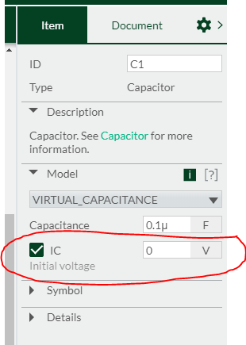
* Set the simulation time step to 1us. Do this by opening the document properties menu, expanding the Maximum time step option, checking the “Manual time step” checkbox and filling “1e-6” in the “Time step” text box.
* In this same menu, change the simulation End time to 25ms by filling “25m” in the “End time” text box.
* In this same menu, change the Initial Conditions to “User defined” by selecting this option from the pull-down menu.

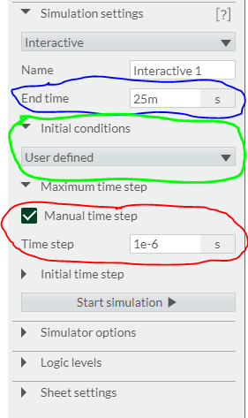

Include one wavelength of the output and capacitor voltage in your answers. You can use the export option in the main menu to output a png file.

Use the Vout waveforms to fill in the Simulation columns in Table 4. You may want to use the cursors function available in the Item tab. If you do not see this tab, double click on a blank area of the timing diagram to make it appear.

Use the Vcap waveforms to fill in the Simulation columns in Table 5. Fill in the Vhigh row with the highest voltage that appears on the Vcap waveform. Fill in the Vlow row with the lowest voltage that appears on the Vcap waveform.

**Assemble Schmitt Trigger Relaxation Oscillator**

This week, you will be soldering in the components associated with the SCHMITT TRIGGER RELATXATION OSCILLIATOR subsystems. This subsystem is named in Figure 5. You should solder in all the components associated with this subsystem and the resistor R10 for the RESET CIRCUIT. Table 2 lists the parts that you will be soldering in this week

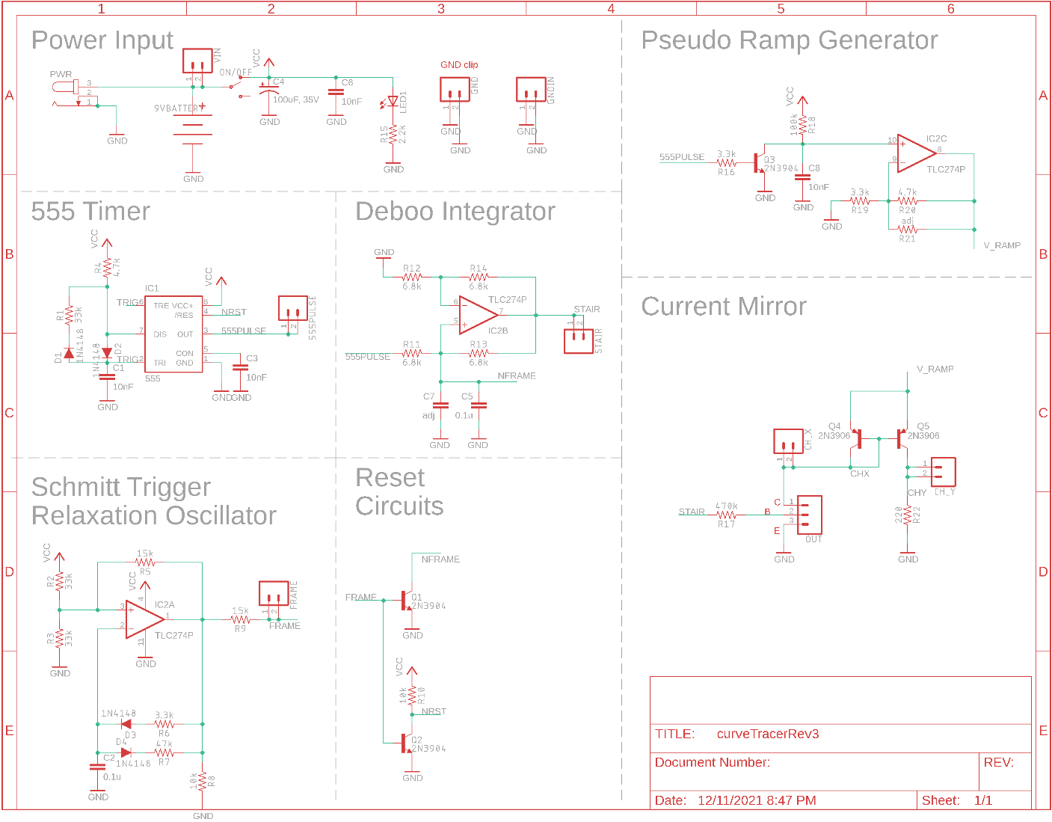

Figure : The schematic for the BJT curve tracer.

Note that capacitor C2 is physically adjacent to the TLC274, outside the **ST Relax Oscillator** outline on the PCB. Be careful to select the correct capacitor from your parts bag. The 0.1uF capacitors are larger and have more spread out leads than the 10nF capacitors.

You will need to solder in the FRAME test point this week using a piece of resistor lead that you trim off.

There are three polarized parts this week, the pair of diodes and the TLC274. Since you are installing a socket for the TLC274, the polarity of the op amp can easily be corrected.

Table : List of parts to be soldered into the PCB this week. Shaded cells are polarized components, watch their orientation.

|  |  |
| --- | --- |
| R2/33k | TLC274 socket |
| R3/33k | R7/47k |
| R5/15k | C2/0.1uF |
| R9/15k | R8/10k |
| D3/1N4148 | R6/3.3k |
| D4/1N4148 | R10/10k |

# To make sure that you can positively identify all the elements in the schematic complete Table 3 by filling in the Match column with the letter that corresponds to the Schematic Symbol in for that Physical Part.

Table : Match the schematic symbol with the corresponding part.

|  |  |  |  |
| --- | --- | --- | --- |
| Schematic Symbol |  | Match | Physical Part |
| A |  | D | Mono-Kap H5 |
| B |  |  | CF 4-7k |
| C |  |  |  |
| D |  |  | DO-35 |
| E |  |  |  |

**Soldering Tips**

Work on being patient with the heat from the solder iron soaking into the PCB pad and the part leads. Use a small dab of liquid solder on the tip of the iron to facilitate heat transfer. When everything is nice and hot, the small dab of solder will wick onto the PCB pad and component lead. When this happens, start melt a small length (less than the join will need) into the interface between the iron tip and the component and PCB pad. Remove the solder while leaving the soldering iron tip in place to make a quick appraisal; can the joint can take a little more solder? If so, add another little dab of solder. When done, remove the solder first then the iron. When you get the knack of it, this should take about 5 second. Work on improving your work from last week – take your time.

When complete your BJT Curve Tracer board should look like Figure 6. Note, I have install the op amp into the socket.

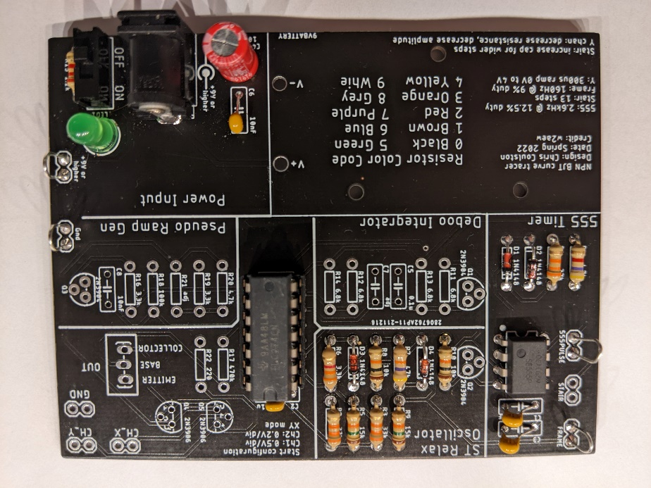

Figure : The completed (for lab 2) BJT Curve Tracer board.

After you solder in all the components you should test and correct any problems.

**Test ST RELAX OSCILLATOR Subsystem**

1. Check the resistance between the “+9V or higher” and “Gnd” test points with the ON/OFF switch in the OFF position. You should get an overload condition on the DMM – there is essentially infinite resistance with the switch in the OFF position.
2. Check the resistance between the “+9V or higher” and “Gnd” test points with the ON/OFF switch in the ON position. This measurement jumps around and may show negative resistance. The value displayed is not meaningful.
3. Power up the BJT curve tracer:
   * Put the ON/OFF switch in the OFF position,
   * Apply power to the board either through your AC/DC converter or using the lab power supply. If you are using the lab power supply, set the voltage to 9V and the current to 100mA,
   * Throw the ON/OFF switch to the ON position,
   * The green LED should illuminate.
4. Power up an oscilloscope, attach a probe to Channel 1 and configure it as follows

|  |  |
| --- | --- |
| Ch1 probe | FRAME test point |
| Ch1 ground clip | GND test point |
| Horizontal (scale) | 1ms |
| Ch1 (scale) | 1V or 2V (whatever fits better) |
| Ch2 probe | Inverting input of op amp |
| Ch2 (scale) | Same as Channel 1 |
| Trigger mode | Auto |
| Trigger source | Ch1 |
| Trigger slope | ↑ |
| Trigger level | 4.5V |

1. Set the GND reference of Ch1 and Ch2 to the lowest visible reticule – the waveforms will overlap the same that they did in the MultiSim simulation. Set the horizontal position of the trigger to the leftmost visible reticule. Note, the op amp output is sent to the FRAME test point. The inverting input of the op amp is available by attaching an oscilloscope probe to the red circled lead shown in Figure 7.

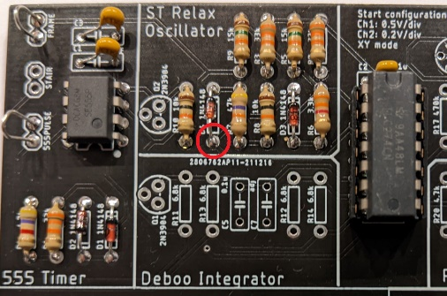

Figure :You can probe the inverting input of the op amp at the red circled lead.

After you get everything setup, screen shot the Vout and Vcap waveforms and include in your lab report. You may want to apply the Acquire function to average 32 waveforms together to smooth the waveforms. Use the data collected from the oscilloscope to fill out the Assemble columns in Table 4, and Table 5.

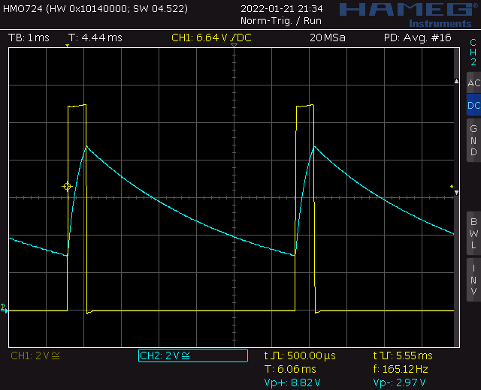

Note this oscilloscope trace was captures on a Rhode&Schwarz HMO724 using a 12V supply for the BJT curve tracer.

**Debugging ST RELAX OSCILLATOR Subsystem**

I would expect most problems with this subsystem to be the result of:

* Bad solder connection
* Diodes soldered in backwards
* Wrong component (resistor or capacitor)

If your BJT curve tracer board fails one of the test steps in the previous section, here is some guidance on what may have happened and how you can correct it.

1. If you are getting low resistance with the ON/OFF switch in the off position:
   * Make sure the ON/OFF switch is in the OFF position,
   * Check that you do not have a solder bridge on the rear of your PCB,
   * Make sure you are reading the DMM correctly. The reading when the ON/OFF switch in the off position should be the same as when you hold the probes apart in air.
2. If you are getting a different resistance with the ON/OFF switch in the on position:
   * Make sure the ON/OFF switch is in the ON position,
   * Make sure you are reading the DMM correctly. The reading when the ON/OFF switch in the ON position will jump around a lot and probably be negative.
3. If the green LED does not illuminate when power is applied ad the ON/OFF switch\ is in the on position:
   * Test that you are applying power. Put a DMM in voltage mode and check the +9V and Gnd test points.
   * Check for solder bridges on the read of the PCB.
4. If you are not getting waveforms that look like the MultiSim Live simulation.
   * Test that the board is powered up.
   * Check that the oscilloscope leads are fully inserted.
   * Press the “Default Setup’” button to undo any weird configuration that the last user may have left the oscilloscope in.
   * Check that solder connections by trying to wiggle each component. There should be no visible movement.
   * Check that all pins of the TLC274 are firmly engaged into the IC socket.

# Turn in:

Make a record of your response to numbered items below and turn them in a single copy as your team’s solution on Canvas using the instructions posted there. Include the names of both team members at the top of your solutions. Use complete English sentences to introduce what each of the following listed items (below) is and how it was derived.

**Analysis Schmitt Trigger Relaxation Oscillator**

Steps 1 – 17

Fill in Analysis columns of Table 4.

Fill in Analysis columns of Table 5.

**Simulation Schmitt Trigger Relaxation Oscillator**

Schematic (use Export -> Schematic Image)

Timing diagram (use Export -> Grapher Image)

Fill in Simulation columns of Table 4.

Fill in Simulation columns of Table 5.

**Assemble Schmitt Trigger Relaxation Oscillator**

Complete Table 3

Fill in Assemble columns of Table 4.

Fill in Assemble columns of Table 5.

**Analysis**

Complete the following table using the information you found in the following sections. Represent your answer in 2 or 3 significant figures using the units given in the quantity column.

Table : Summary of Vout behavior in the Schmitt Trigger Relaxation Oscillator.

|  |  |  |  |
| --- | --- | --- | --- |
| Quantity | Analysis | Simulation | Assemble |
| Time high (us) |  |  |  |
| Time low (us) |  |  |  |
| Period (us) |  |  |  |
| Frequency (kHz) |  |  |  |
| Duty Cycle |  |  |  |

Table : Summary of the 0.1uF capacitor voltage in the Schmitt Trigger Relaxation Oscillator.

|  |  |  |  |
| --- | --- | --- | --- |
| Quantity | Analysis | Simulation | Assemble |
| Vhigh |  |  |  |
| Vlow |  |  |  |